Recursive Constraint Compression and Transformation-Space Reduction
Layer 2 Provisional Patent

Field of the Invention
The present disclosure relates generally to computational systems, artificial intelligence, graph systems, planning systems, optimization systems, representation learning systems, biological modeling systems, and recursive computational architectures.
More specifically, the disclosure relates to systems and methods for:
- recursively compressing transformation spaces,
- recursively reducing computational search complexity,
- recursively preserving valid traversal structure,
- recursively coarsening structured state spaces,
- preserving reachability and path consistency across abstraction scales,
- and performing computation within recursively compressed transformation-preserving systems.
The disclosed systems may operate within:
- artificial intelligence systems,
- world-model architectures,
- planning systems,
- navigation systems,
- robotics systems,
- transfer-learning systems,
- graph systems,
- biological systems,
- latent-space systems,
- distributed systems,
- or recursively organized computational architectures.

Background of the Invention
Many computational systems operate within extremely large transformation spaces.
Examples include:
- artificial intelligence systems,
- planning systems,
- graph traversal systems,
- biological sequence systems,
- reinforcement-learning systems,
- robotic navigation systems,
- world-model architectures,
- optimization systems,
- and latent representation systems.
In conventional systems:
- transformations are often treated independently,
- state spaces grow combinatorially,
- invalid states remain explorable,
- planning complexity increases rapidly,
- and computational systems frequently fail to preserve meaningful multi-scale structure.
Existing dimensionality reduction and compression systems often:
- prioritize storage reduction,
- reduce dimensionality without preserving valid traversal structure,
- collapse meaningful transformation relationships,
- or fail to preserve navigational consistency across abstraction scales.
Similarly, many planning and inference systems:
- generate unconstrained trajectories,
- explore invalid state regions,
- or fail to preserve path consistency during abstraction or compression.
Conventional graph coarsening systems also frequently:
- lose meaningful reachability structure,
- distort traversal geometry,
- break shortest-path consistency,
- or fail to preserve valid transformation systems.
As computational systems scale:
- independently learnable relationships increase,
- search spaces become computationally expensive,
- planning systems become inefficient,
- and inference systems increasingly rely on brute-force optimization.
Accordingly, there exists a need for systems capable of:
- recursively compressing transformation structure,
- preserving valid traversal relationships,
- reducing effective search complexity,
- recursively preserving reachability,
- preserving navigational consistency across scales,
- and maintaining transformation-preserving geometry during recursive abstraction.

Summary of the Invention
The present disclosure provides systems and methods for recursive constraint compression and recursive transformation-space reduction.
In various embodiments:
- transformation spaces are recursively compressed into recursively organized abstraction systems,
- recursively equivalent transformations are grouped into higher-order structures,
- recursively generated abstraction layers preserve valid traversal,
- and recursive compression preserves meaningful reachability relationships across scales.
Unlike conventional compression systems, the disclosed systems preserve:
- valid transformation structure,
- navigational consistency,
- recursive reachability,
- shortest-path relationships,
- functional neighborhoods,
- recursive equivalence systems,
- or recursively induced geometry.
In some embodiments:
- recursively compressed systems reduce independently searchable relationships,
- recursively organized abstraction systems reduce planning complexity,
- recursive compression preserves valid traversal geometry,
- and recursively generated abstraction systems preserve meaningful path structure.
In some embodiments:
- recursive coarsening preserves valid navigation,
- recursively induced abstraction preserves transformation consistency,
- recursively compressed systems preserve planning trajectories,
- and recursive compression reduces invalid state exploration.
In various embodiments:
- recursively compressed systems preserve local and global consistency simultaneously,
- recursive abstraction supports multi-scale planning,
- recursively generated reachability systems preserve accessibility relationships,
- and recursively induced geometry constrains traversal and inference.
The disclosed systems may operate over:
- graph systems,
- geometric systems,
- biological systems,
- symbolic systems,
- manifold systems,
- latent systems,
- planning systems,
- or recursively organized state spaces.

Figure Descriptions

FIGURE 1 — Recursive Transformation-Space Compression
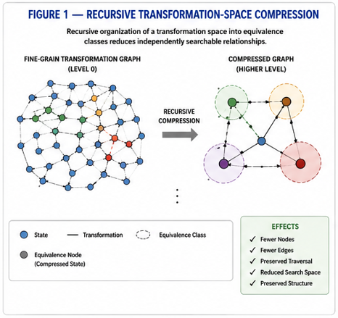
Figure 1 illustrates recursive compression of a transformation space.
In some embodiments:
- lower-order transformation systems are recursively organized into higher-order equivalence structures,
- recursively equivalent transformations are compressed into shared relational systems,
- and recursive organization reduces independently searchable transformation relationships.
Figure 1 may illustrate:
- transformation graphs,
- recursive equivalence classes,
- recursively compressed traversal systems,
- or recursively reduced search spaces.

FIGURE 2 — Recursive Coarsening and Path Preservation
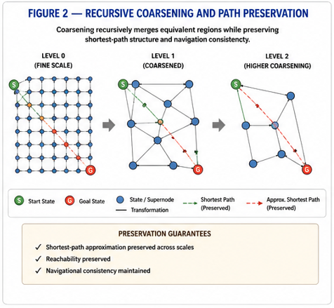
Figure 2 illustrates recursive coarsening of a structured state space while preserving traversal consistency.
In some embodiments:
- recursively generated abstraction layers preserve shortest-path relationships,
- recursively compressed systems preserve valid reachability,
- and recursively coarsened structures preserve navigational consistency across scales.
Figure 2 may illustrate:
- fine-scale graphs,
- recursively coarsened graphs,
- preserved traversal pathways,
- preserved reachability systems,
- or hierarchical abstraction layers.

FIGURE 3 — Recursive Reachability System
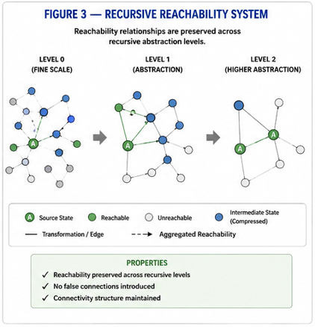
Figure 3 illustrates recursive preservation of reachability relationships across recursively compressed abstraction levels.
In some embodiments:
- recursively generated abstraction systems preserve valid navigation,
- recursively compressed systems preserve accessibility relationships,
- and recursively organized traversal systems preserve multi-scale connectivity.
Figure 3 may illustrate:
- recursive navigation maps,
- recursive accessibility graphs,
- recursive planning pathways,
- or recursively linked abstraction systems.

FIGURE 4 — Multi-Scale Recursive Planning Architecture
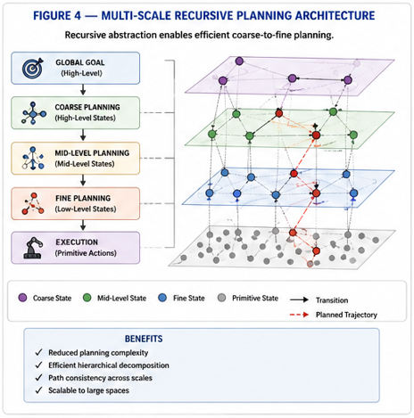
Figure 4 illustrates recursive planning within recursively compressed state systems.
In some embodiments:
- coarse recursive levels define global planning structure,
- fine recursive levels define local traversal,
- recursively linked abstraction systems preserve path consistency,
- and recursive compression reduces planning complexity.
Figure 4 may illustrate:
- hierarchical planning systems,
- recursive abstraction layers,
- coarse-to-fine traversal,
- recursive planning trajectories,
- or recursively compressed world-model systems.

FIGURE 5 — Recursive Symmetry Compression System
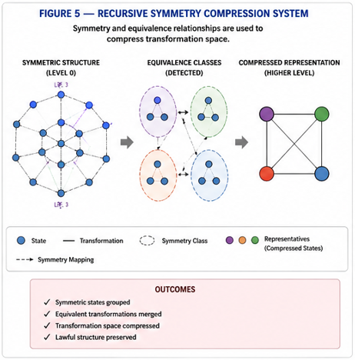
Figure 5 illustrates recursive compression through recursively preserved symmetry relationships.
In some embodiments:
- recursively equivalent transformations are grouped into shared relational systems,
- recursively generated symmetry systems reduce independently searchable transformations,
- and recursive organization compresses lawful traversal structure.
Figure 5 may illustrate:
- rotational equivalence systems,
- recursive symmetry neighborhoods,
- recursively generated equivalence structures,
- or recursively compressed transformation grammars.

FIGURE 6 — Recursive Generative Compression System
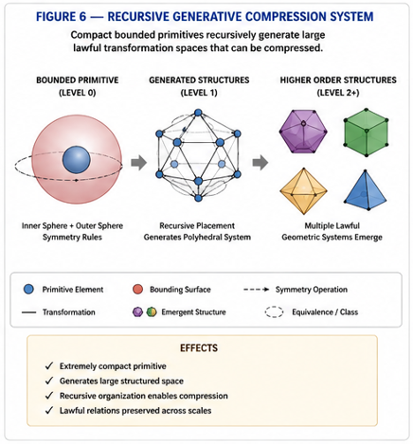
Figure 6 illustrates generation of large lawful transformation systems from compact bounded relational primitives.
In some embodiments:
- recursively organized bounded systems generate higher-order transformation spaces,
- recursively generated neighborhoods induce recursively compressible relational structure,
- and recursive symmetry systems preserve lawful traversal relationships during compression.
Figure 6 may illustrate:
- recursive sphere systems,
- recursive polyhedral emergence,
- recursively generated adjacency systems,
- recursive transformation grammars,
- or recursively induced multi-scale geometry.

Core Definitions

Transformation Space
A transformation space comprises:
- states,
- permissible transformations,
- traversal relationships,
- reachability relationships,
- adjacency systems,
- or recursively organized relational structures
through which computation, traversal, planning, inference, or optimization may occur.
In some embodiments:
- compact bounded relational primitives recursively generate large lawful transformation systems,
- recursively generated equivalence relationships compress traversal complexity,
- and recursively induced symmetry systems reduce independently searchable transformation relationships.
In some embodiments:
- recursive symmetry-preserving organization acts as a compression mechanism for transformation space itself.

Bounded Transformational Substrate
A bounded transformational substrate comprises a recursively organizable relational structure configured to constrain permissible transformations, adjacency systems, equivalence relationships, and traversal pathways.
In some embodiments:
- substrate structure determines transformation compressibility,
- recursively organized substrates preserve lawful traversal,
- and recursive compression preserves substrate-defined reachability relationships.

Recursive Constraint Compression
Recursive constraint compression refers to recursively reducing effective transformation-space complexity while preserving valid transformation structure.
In some embodiments:
- recursively equivalent transformation systems are grouped,
- recursively generated abstraction layers preserve valid traversal,
- and recursive compression reduces independently searchable relationships.
Recursive compression may preserve:
- reachability,
- path consistency,
- navigational structure,
- recursive equivalence,
- shortest-path relationships,
- or recursively induced geometry.

Recursive Symmetry Compression Systems
In some embodiments, recursive compression operates through recursively preserved symmetry systems.
Recursive symmetry compression may include:
- rotational equivalence systems,
- recursively generated neighborhood symmetry,
- recursive adjacency equivalence,
- recursively preserved transformation symmetry,
- or recursively composable geometric equivalence systems.
In some embodiments:
- recursively symmetric transformations are compressed into shared traversal systems,
- recursively generated equivalence classes preserve lawful transformation structure,
- and recursive symmetry systems reduce independently searchable relationships.
In some embodiments:
- recursively organized bounded primitives generate recursively compressible lawful transformation systems across multiple scales.

Recursive Coarsening
Recursive coarsening refers to recursive abstraction of state spaces into higher-order relational systems.
In some embodiments:
- lower-order neighborhoods recursively merge into higher-order regions,
- recursively generated abstraction systems preserve valid traversal,
- and recursive coarsening preserves meaningful transformation relationships.

Path Fidelity
Path fidelity refers to preservation of valid traversal structure across recursively compressed abstraction levels.
In some embodiments:
- recursively compressed systems preserve shortest-path approximations,
- preserve navigational accessibility,
- preserve recursive reachability,
- or preserve valid transformation trajectories.

Recursive Reachability
Recursive reachability refers to preservation of accessibility relationships across recursive abstraction levels.
In some embodiments:
- recursively generated abstraction systems preserve valid navigation,
- recursively compressed systems preserve transformation accessibility,
- and recursive traversal systems preserve multi-scale connectivity.

Substrate-Dependent Compression
In some embodiments, recursive compression depends on the structure of the underlying transformational substrate.
Different substrates naturally permit different:
- equivalence systems,
- adjacency structures,
- transformation grammars,
- traversal pathways,
- recursive compressibility properties,
- or lawful transformation organizations.
In some embodiments:
- recursively organized bounded substrates preserve lawful equivalence structure,
- recursive symmetry systems compress transformation complexity,
- and recursively induced substrate geometry reduces independently searchable relationships.
In some embodiments:
- sphere-based substrates preserve bounded neighborhood organization and rotational equivalence relationships that support recursive compression.

Recursive Equivalence System
A recursive equivalence system recursively organizes transformations, neighborhoods, or states into equivalence structures according to:
- transformation similarity,
- navigational similarity,
- reachability similarity,
- functional equivalence,
- or recursively preserved relational structure.

Generative Compression
Generative compression refers to generation of large structured transformation systems from compact bounded relational primitives.
In some embodiments:
- recursively organized bounded systems generate higher-order lawful transformation spaces,
- recursively generated equivalence systems reduce independently representable relationships,
- and recursively generated structure compresses effective computational complexity.
In some embodiments:
- recursive symmetry operations generate recursively reusable transformation systems,
- recursively generated neighborhoods preserve lawful traversal,
- and recursively induced geometry reduces transformation redundancy.

Recursive Abstraction Layer
A recursive abstraction layer comprises a recursively generated higher-order representation preserving valid traversal relationships from lower-order systems.
Recursive abstraction layers may preserve:
- navigational consistency,
- path fidelity,
- recursive reachability,
- functional traversal,
- or recursively induced geometry.

Recursive Compression Framework
In some embodiments, recursive compression proceeds according to:
$S^{\left(k+1\right)}=C\left(S^{\left(k\right)},E^{\left(k\right)},P^{\left(k\right)}\right)$
where:
- $S^{\left(k\right)}$ represents a state space at recursive level $k$,
- $E^{\left(k\right)}$ represents equivalence relationships,
- $P^{\left(k\right)}$ represents path-preservation constraints,
- and $C$ represents a recursive compression operator.
In some embodiments:
- recursively compressed systems preserve traversal consistency,
- recursive abstraction preserves valid reachability,
- and recursively generated abstraction layers preserve meaningful navigation.

Recursive Path-Preservation Framework
In some embodiments, recursive path preservation proceeds according to:
$P^{\left(k+1\right)}=f\left(P^{\left(k\right)},R^{\left(k\right)},C^{\left(k\right)}\right)$
where:
- $P^{\left(k\right)}$ represents path structure at recursive level $k$,
- $R^{\left(k\right)}$ represents reachability structure,
- $C^{\left(k\right)}$ represents compression structure,
- and $f$ represents a recursive path-preservation function.
In some embodiments:
- recursively compressed systems preserve shortest-path approximations,
- preserve navigational accessibility,
- preserve traversal consistency,
- or preserve recursive connectivity.

Technical Improvements
The disclosed systems improve computational functionality by:

1. Reducing Effective Search Complexity
Recursive compression reduces:
- independently searchable relationships,
- invalid traversal exploration,
- and transformation-space complexity.

2. Preserving Valid Traversal Structure
Unlike conventional compression systems, recursively compressed systems preserve:
- valid reachability,
- recursive path structure,
- navigational consistency,
- and transformation-preserving traversal.

3. Improving Multi-Scale Planning
Recursive abstraction layers support:
- coarse-to-fine planning,
- hierarchical navigation,
- recursive reachability,
- and scalable traversal systems.

4. Improving Representation Efficiency
Recursive equivalence systems reduce:
- redundant transformation learning,
- representation instability,
- and independently learnable relationships.

5. Improving Transfer and Generalization
Recursively preserved transformation systems improve:
- transfer compatibility,
- abstraction consistency,
- recursive traversal stability,
- and preservation of meaningful relational structure.

6. Recursive Generative Compression
In some embodiments:
- compact bounded relational primitives recursively generate higher-order lawful transformation systems,
- recursively generated equivalence structures compress traversal complexity,
- recursively induced geometry preserves lawful reachability,
- and recursive symmetry systems reduce independently representable transformation relationships.
In some embodiments:
- recursive generative compression preserves navigational consistency while reducing effective search complexity.

7. Improving Transformation Compressibility Through Substrate Organization
Bounded transformational substrates may:
- reduce independently representable transformations,
- preserve lawful equivalence structure,
- reduce transformation redundancy,
- improve recursive compressibility,
- and preserve navigational consistency during abstraction.

Distinction From Conventional Systems
In conventional systems:
- compression often destroys traversal structure,
- abstraction layers may lose navigational consistency,
- planning systems explore invalid trajectories,
- and coarsening systems fail to preserve meaningful reachability.
In contrast, the present disclosure:
- recursively preserves transformation structure,
- recursively preserves valid traversal,
- recursively preserves path consistency,
- and recursively preserves meaningful reachability during abstraction and compression.
In some embodiments:
- computation occurs within recursively compressed transformation-preserving systems rather than unconstrained reduced representations.

